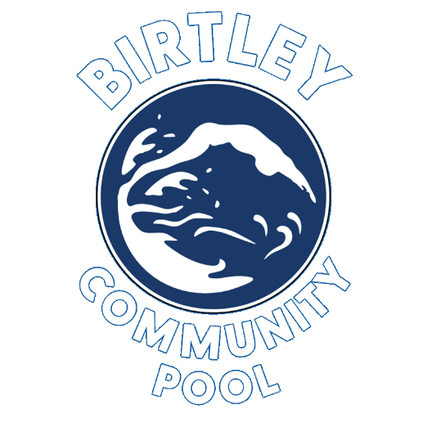
Birtley Community Aquatic Centre (BCAC)
Job Vacancy – Leisure attendant
Full Time: Average of 37.5 hours per week including early / late weekday shifts and early weekend shifts
Part Time: Between 20 and 30 hours per week including early / late weekday shifts and early weekend shifts
Casual: On zero hours contracts, up to 16 hours per week
Salary: Equivalent to NJC PO2 scale £24,027 (pro rata) – pay award pending
We are looking for enthusiastic and flexible leisure attendants with a “can do” attitude to join our team. Those who are proactive in meeting customer needs and maintaining high standards of health and safety and cleanliness are encouraged to apply. A commitment to continuous professional development (CPD) is necessary and knowledge of Health and Safety standards is vital.
Essential Qualifications for the Role:
- A valid Royal Life Saving Society (RLSS) National Pool Lifeguard Qualification (NPLQ) or equivalent. Including a swimming depth and speed test, once employed.

Please see attached job description and personal specification for further information.
Birtley Community Aquatic Centre
Job Description – Leisure Attendant
Responsibilities include (but are not limited to):
- Ensuring the safety of customers when undertaking lifeguarding duties for all pool activities.
- Always engaging with customers in a polite and respectful manner, following the direction of your duty manager.
- Providing a safe, friendly, and efficient environment for those accessing the building, including carrying out receptionist and administration tasks. This will include cash handling, updating memberships and taking bookings whilst adhering to GDPR and data protection legislation.
- Undertaking and documenting operational and maintenance tasks required for the pool plant and equipment as well as responding to breakdowns or defects in line with Centre policy and procedure and relevant legislation.
- Ensure these operational and maintenance tasks are completed safely and within a set time to an expected standard and working within COSHH guidelines when using and storing chemicals.
- Taking a positive approach to customers and day -to -day operational duties whilst maintaining Health and Safety standards and cleanliness throughout the working day within both the building and grounds, in compliance with risk assessments, policies and procedures, Standard Operating Procedures (SOP) and Emergency Action Plans (EAP).
- Regular rotation between activities to ensure sufficient breaks from lifeguarding are taken as per legislation.
- Maintaining own current Pool Lifeguard qualification and other qualifications relating to the role. Monthly staff training will be provided, and staff will be paid for attending one of these two-hour sessions which are required to maintain your qualifications and allow you to work the next month.

All the above duties and responsibilities specified above may vary as need dictates. Members of our team are expected to undertake other duties relevant to their position as required. These duties should be within the remit of the employee or volunteer’s role.
Equal Opportunities: The post holder must carry out their duties with full regard to Equal Opportunities legislation and best practice.
Disclosure & Barring Service: All appointments are subject to the satisfactory outcome of an enhanced DBS check.
Organisational Structure: Leisure attendants will report to a duty manager. They will help supervise volunteers, work experience trainees and newer staff members, working as part of a team to maintain a safe environment.
Birtley Community Aquatic Centre
Personal Specification – Leisure Attendant
 | Essential | Desirable | Identified by:
Qualifications and Knowledge | - Current RLSS National Pool Lifeguard Qualification or equivalent, but willing to achieve the RLSS qualification, including a swimming depth and speed test, once employed.  - A minimum of a GCSE in Maths and English at grade A-C (or equivalent).  - Ability to read, understand and follow policies and procedures.  - Willingness to undertake staff training and CPD.  - IT literate. | - Experience of working in a sports environment.  - First Aid at Work Qualification,  - Safeguarding Children in Sport Certificate.  - Swim England Level 1 or 2 (Swimming) Teaching Certificate.  - Swim Teacher rescue qualification.  - RLSS Trainer Assessor qualification.  - Certificate in Pool Plant Operation.  - Operational experience of swimming pools.  - Aquafit coaching experience and qualification.  - Experience of working within an administrative role. | - Supporting documents.  - Application form  - Interview.
Attributes | - Organised and effective team player.  - Excellent communication skills.  - Ability to work with a variety of people from all walks of life.  - Flexible and willing to undertake new and other tasks as required in a safe manner.  - A problem solver who can provide high quality customer service.  - Willing to assist with training and CPD as required. | - An understanding of the following: retail sales, pool plant, membership sales, delivery of staff training sessions.  - Experience of using a till and working within a cash-handling role. | - Supporting documents.  - Application form  - Interview.
Personal Skills and Qualities | - Self-motivated whilst being able to work as part of an effective team.  - Always punctual.  - Able to cope with periods of physical and mental demand, including periods of concentration whilst lifeguarding the pools.  - Solving problems and ability to organise and plan to prevent problems and achieve outcomes.  - The ability to meet the needs and requirements of the customers in all aspects of the business.  - Ability to follow set down procedures and have an input into improvement of systems when required.  - Ability to identify and report matters of relevance to line manager.  - Ability to adapt to change as required. | - Enthusiastic about swimming.  - Able to demonstrate commitment to an organisation.  - A willingness to help improve and develop the centre. | - Supporting documents.  - Application form  - Interview.

