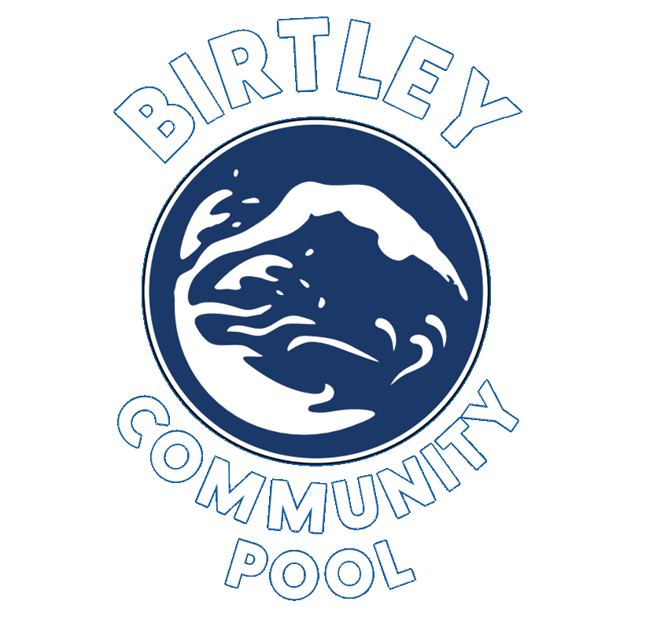

Birtley Community Pool
Complaints and Customer Service Policy

Version: 1.0
Revision Date: September 2025
Next Review Date: September 2026

1. Introduction
Birtley Community Pool is committed to delivering high standards of customer service. We value feedback from customers—whether positive or negative—as a tool for continual improvement. This policy outlines how we manage compliments, comments, and complaints.

2. Our Commitment
We aim to:
- Provide a friendly, professional, and safe environment.
- Respond promptly, fairly, and clearly to all feedback and complaints.
- Use feedback to inform staff training and development, improve our services, and enhance customer experience.

3. Organisational Responsibilities
- Board of Trustees: Provides governance and oversight. May be consulted for serious complaints involving safeguarding, legal risk, reputational harm, or unresolved escalations.
- Senior Operations Manager: Has overall responsibility for managing complaints and ensuring customer service standards across the centre. Reports serious or unresolved issues to the Chair or Board as appropriate.
- Lead Leisure Attendants: Manage day-to-day service delivery and are the first point of escalation for on-site concerns.
- Leisure Attendants: Deliver frontline service to customers. They are trained to handle minor concerns and direct more serious issues to a Lead.
- Business Support Manager: Maintains records of complaints, monitors communication channels, ensures responses are timely and appropriate, and advises management on trends or issues.

4. How to Provide Feedback or Make a Complaint
Customers can give feedback or raise concerns:
- In person with any staff member at the pool.
- Via phone or email (contact details posted at reception and on our website).
- Through our official social media pages.
- Using the feedback QR codes around the building.

5. Handling Complaints: Process Overview
Stage 1 – Informal Resolution
- Customers are encouraged to speak to a Leisure Attendant or Lead Leisure Attendant immediately.
- Wherever possible, staff will resolve the issue on the spot.
- If the issue cannot be resolved or requires further attention, it will be escalated to the Business Support Manager.
Stage 2 – Formal Complaint
- If a customer is unsatisfied with the outcome of the informal resolution, they may submit a written complaint (email, feedback form, or letter).
- The Business Support Manager logs and acknowledges the complaint within 3 working days.
- The Business Support Manager investigates and responds within 10 working days.
Stage 3 – Escalation to Senior Leadership
- If the customer remains dissatisfied, the matter will be reviewed by the Senior Operations Manager.
- If the issue is complex, involves safeguarding, significant operational failure, or remains unresolved, it may be escalated to the Chair of the Board of Trustees for governance-level review.
- The Board will consider the issue and respond within 30 working days. The Chair’s decision is final.

6. Recording and Monitoring
- All formal complaints are recorded by the Business Support Manager in a central log.
- Complaint trends will be reviewed quarterly and reported to the Board of Trustees to support governance and service improvement.

7. Staff Conduct and Training
- All staff are trained in customer care, including how to receive feedback and handle complaints professionally and empathetically.
- Regular updates are provided on complaint handling procedures and service expectations.
- Any complaints which relate to a specific staff member will be discussed with the staff member as soon as possible after the complaint is received as part of the complaint investigation, including identifying and agreeing any changes which may be required in the behaviours or way of working for the staff member.
- The complaint may also be included in the feedback at the next 121 for the member of staff.
- Guidance may be provided to all staff on either behaviours or way of working in the employee newsletter following a customer complaint investigation

8. Confidentiality and Data Protection
All complaints are treated confidentially and in line with data protection legislation. Personal details will only be shared with relevant staff or trustees involved in investigating or responding to the complaint.

9. Unreasonable or Abusive Complaints
We reserve the right to refuse service or disengage from complaints that are abusive, repetitive without new evidence, unreasonable in nature or clearly intended to harass staff. Any such incidents will be reported to the Senior Operations Manager and may be escalated to the Chair of the Board if necessary.

10. Review of This Policy
This policy will be reviewed annually by the Senior Operations Manager in consultation with the Board of Trustees.

11. Contact Information
For any questions or clarifications regarding the Complaints and Customer Service Policy, please contact:
- Senior Operations Manager
Lewis Herbertson
Lewis.Herbertson@birtleycommunitypool.org.uk
- Business Support Manager
Amber Barry
Amber.Barry@birtleycommunitypool.org.uk

12. Approval
This policy was approved by the Board of Trustees of Birtley Community Pool on September 2025.
Signatories:
Yvonne Probert
Chairperson, Birtley Community Aquatic Centre Board of Trustees
Tracy Green
HR Trustee, Birtley Community Aquatic Centre Board of Trustees

